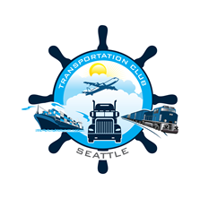
TRANSPORTATION CLUB OF SEATTLE
2023 Scholarship Application
TRANSPORTATION CLUB OF SEATTLE
www.transportationclubofseattle.org

Email: transportationclubofseattle@gmail.com

TRANSPORTATION CLUB OF SEATTLE

Letter from the President

Dear Applicants,
The Transportation Club of Seattle has been actively involved in the Pacific Northwest’s transportation industry since 1910, working to develop this vital and exciting industry that has been a key factor in the region’s growth and success.
Our Scholarship program has been developed to encourage interest in the transportation industry with the goal of developing the next generation of transportation professionals. Successful applicants will possess strong academic skills and an interest in developing knowledge and skills related to transportation industry.
We encourage you to look further into this ancient yet ever evolving industry by taking the opportunity to visit with us and apply for our Club’s Scholarship Program.
I look forward to congratulating each scholarship recipient in person at our annual scholarship awards luncheon.
Best Regards,
Steve Balaski
President
Transportation Club of Seattle
TRANSPORTATION CLUB OF SEATTLE

History of the Club

The Transportation Club of Seattle was formed in 1910 to encourage study of transportation issues by its members; to sponsor educational programs and discussions pertaining to traffic and transportation matters; to use all proper means to inform the general public of the functions of the traffic profession, in order to create a better understanding and appreciation thereof; to act upon traffic and transportation matters of common interest to the membership; to promote acquaintance, good fellowship and closer business relationship between persons identified with the transportation of persons or property, and to progress the welfare of its membership.

Our members come from all types of industry segments including airlines, trucking companies, logistics providers, firms involved in supply chain management, government, ocean lines and railroads.

We hold regular monthly luncheon meetings and events enabling members and guests to meet in an atmosphere of fellowship to share information and ideas regarding the transportation industry affecting our local area. While the Club offers its members a great networking opportunity, the membership also provides the community with significant contributions to local charities and a scholarship fund to support the future of our industry.

Best Regards,

The Board of Directors

THE SCHOLARSHIP
Our Scholarship program has been developed to encourage members of our club and their family members to better their lives through higher education. Successful applicants will possess strong academic skills and be successfully enrolled in a program of study that will lead to an associate degree or higher, or a certificated program. One or more scholarships of at least $500 each will be awarded.

WHO MAKES THE DECISIONS?
The Transportation Club of Seattle Scholarship Program is administered by a three-member panel, consisting of existing board members and active or retired club members, with oversight by the Club President. Board members on this committee can act as sponsors for any applicants however in such an instance, the committee member would abstain from evaluating that application. The board determines the number and amount of the scholarships given out.
SELECTION CRITERIA
Scholarships will be awarded on scholastic merit, ability, and character, without regard to race, sex, color, creed or intended or actual field of study. The awards are to be used by students who, through their efforts, achievements, community service and character, have demonstrated their ability to benefit themselves and others, through continuing education.
WHO IS ELIGIBLE?
To be eligible for a scholarship you must meet ALL the following general requirements:
- Must be a TCS member or relative by blood or marriage of a current TCS member with at least 1 year of good standing membership or be a current Transportation Club of Seattle Mentee. Qualifying membership/mentorship must be for the year prior to the current award season.
- Must be sponsored by a current member (member applicants can act as their own sponsor)
- Must be enrolled or plan on enrolling in an accredited college or university by the following Fall term.
- Minimum GPA of 2.5 or comparable evaluation (i.e., Pass/Fail college)
- Current school transcript through Fall term. An official student copy is acceptable.
- Must have 2 letters of recommendation.
- Letters of recommendation must be from a current teacher/professor, school administrator, or manager; and they must be written within the twelve months leading up to the application deadline.
- Completed application including the essay.
- Must submit the following items with all required information in a PDF format via email.
  - Completed application
  - Letters of recommendation
  - Essay

WHAT ELSE SHOULD I KNOW?
- Each award is for one year; students must re-apply for consideration the following year. No applicant may receive more than four total scholarship awards while part of a certificate, associate, or undergraduate program and 3 awards while part of a graduate or advanced degree program.
- Successful applicants will be asked to supply a picture of themselves for publication in our newsletter and website.
- Successful candidates will also be asked to attend our June Scholarship Luncheon in Seattle where we will formally recognize the scholarship recipients.
- Scholarship monies are paid
directly to registrar of recipients’ actual college or university. In the event of non-enrollment in the Fall term, monies will be returned to the Club for use at the board’s discretion.
- Applications are due no later than April 30, 2023.

INFORMATION

INFORMATION

HOW TO APPLY
In order to be considered, you must submit an application package which includes the following items. Applications missing any of the four items will be considered incomplete and may be excluded from consideration.
Item 1: Part 1 of the Application Form.
Item 2: Current academic transcript through the Fall term. An official student copy is acceptable.
Item 3: A total of two letters of recommendation from a current teacher/professor or school administrator.
Letters must be written and dated within twelve months of April 30, 2023.
Item 4: Submit an essay (Part 2) no longer than two pages, double spaced, answering the essay subject posed in
Part 2 of the application form.
Submit the application package as a single file in a PDF format. Please scan all documents into a single file that can be attached to an email.
Applications must be sent electronically via email to transportationclubofseattle@gmail.com AND tcsscholarshipcommittee@gmail.com
Applications are due no later than April 30, 2023.

Note: If unable to submit an electronic version, please contact the Board in advance to discuss alternative submission options.

HOW DO I FIND OUT MORE ABOUT THE TRANSPORTATION CLUB OF SEATTLE ?
All applicants are encouraged to take a few moments to explore our website at www.transportationclubofseattle.org.
For specific scholarship questions, you may contact the club via email transportationclubofseattle@gmail.com or the Scholarship chair, Tamara Kulp, at tcsscholarshipcommittee@gmail.com or 206-654-3706.
Thank you for your interest in the Scholarship Program,

The Board of Directors

INFORMATION

PART 1: Fill out completely. Please Type or Print clearly in BLACK INK. All materials must be submitted in English.
Student Information
Legal Name: Enter name exactly as it appears on official documents.
Last First Middle Suffix
Address
Street State Zip Code
City Home Phone ( )
E-mail Cell Phone ( )
Date of Birth (mm/dd/yy)

High School Information
Name of High School
MM/YY of HS Graduation
High School GPA
College Information
College Student Plans on Attending College Student ID
College Address (include required routing for potential College GPA
scholarship check.)
Class Year Next Fall
Academic Interest/Major

College Phone Number
Other

Have you ever received the Transportation Club of Seattle Scholarship before? Yes No
If Yes, then please advise which years you received the award:

APPLICATION

Awards
List awards or honors you have received and briefly explain their significance. List date received in mm/yy format.
Award/Honor | Significance | Date Received
Employment
List any jobs you have held over the last three years during your high school and/ or college years, including summers. Please include your responsibilities and hours worked.
Employer | Job/Responsibilities | From (mm/yy) | To (mm/yy) | Hrs. Per Week
Community/Volunteer Activities
List community activities in which you have participated without pay during your high school years Please do not abbreviate organization names. List dates of participation in mm/yy format.
Organization | Activity/Service | Dates of Participation | Hrs. Per Week

APPLICATION

Activities
School Activities: List high school-related/college activities in which you have participated. Do not abbreviate activity names. List dates of participation in mm/yy or season/yy format.
Activity | Office(s) Held | Date of Participation | Hours Per Week
Signatures
The following signatures are required as part of the application process. Failure to complete this section will result in this application being removed from consideration.

Sponsor Signature

By signing my name, I certify that I am a current member of the Transportation Club of Seattle and that I do in fact wish
to act as applicants sponsor for this 2023 TCS scholarship application.
Note: Member Applicants may act as their own sponsor
Member Sponsor Name: Relation:
Member Sponsor Signature: Date:

Applicant Signature

By signing my name, I certify all information on this application and all enclosures are true and accurate to the best of my knowledge and that any misrepresentation may cause the club to disqualify the applicant from consideration or rescind the scholarship.

Applicant Name:

Applicant Signature: Date:
APPLICATION

PART 2 -Failure to complete this section will result in this application being removed from consideration.
Essay Section
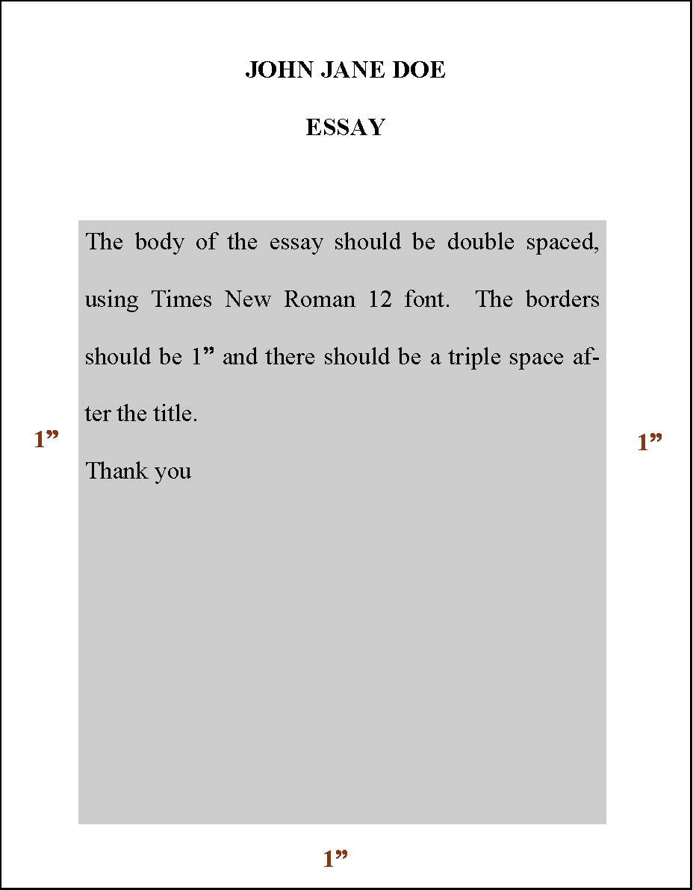
Essay Format: Use 8 ½” x 11” white paper; type or use a computer. Maximum length should not exceed two pages. Use your NAME and ESSAY as the title (see below). Triple-space after the title and double-space the body of your essay using 1” margin all around, size 12 Times New Roman font. Failure to complete this section using the stated guidelines will result in this application being removed from consideration.
Essay Subject: Write an essay about why you deserve to receive a scholarship from the Transportation Club of Seattle. Please include information about your educational, career and personal goals and how a scholarship award would help you to achieve those goals. Demonstrate your talent by writing about any special interests or special circumstances that you may wish the selection committee to consider.

